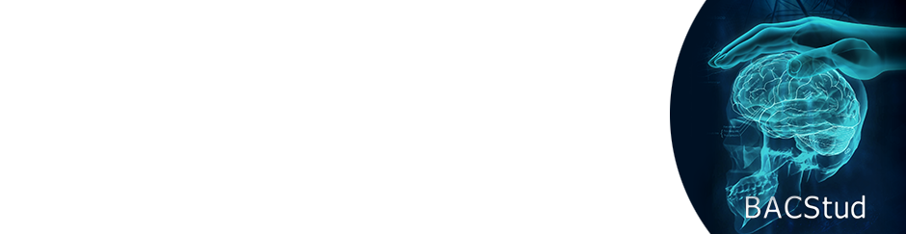

International Symposium “Brainstorming in Agora Students’ Scientific Circle“
BACStud2026
12th Edition
Băile Felix – Oradea
October 8–10, 2026

AGREEMENT FORM FOR PAPER PUBLICATION
BACSTUD 2026 International Symposium
Title of the paper:
..........................................................................................................................................................
Author(s):
..........................................................................................................................................................
The undersigned author(s) hereby declare that:
- The paper is original and has not been previously published, in whole or in part, in any printed or electronic publication;
- The paper does not infringe upon the copyright of any other individuals or entities;
- All authors agree with the content of the paper and its presentation at the BACStud 2026 Symposium.

By completing this form, the author(s) give their consent for the paper to be published by the organizers of the BACStud 2026 conference in electronic format, on a digital medium (USB stick with ISBN).

This publication is non-exclusive, meaning that the authors retain all other rights to the work and may republish it elsewhere, provided that the initial appearance at BACStud 2026 is properly cited in the bibliography.

Name and Surname:
........................................................................................
Signature:
........................................................................................
Date:
...............................................................

